ISSUED UNDER EMBARGO UNTIL 00:01 THURSDAY NOVEMBER 28TH
Majority across 28 countries say investment in infrastructure is vital for future economic growth and much more is needed
- Majority of citizens comfortable with private investment in infrastructure
- Future infrastructure priorities should focus on addressing the climate agenda
- First global “Nimby Index” shows where and what might cause local opposition to infrastructure projects
76% of citizens across 28 countries see investment in infrastructure as vital to their countries’ future economic growth. However, 60% think their country is not doing enough to meet its infrastructure needs.
The findings come from the latest Global Infrastructure Index survey conducted by Ipsos in partnership with the Global Infrastructure Investor Association (GIIA). The survey collected ratings for 14 infrastructure sectors with airports (67% rate these as very/fairly good), digital (55%), water supply and sewerage (also 55%) and motorways (54%) receiving the best ratings - sectors where private ownership and operation is prominent. Globally, citizens are least positive about current infrastructure related to electric vehicle charging (24%), flood defences (31%), solar energy (33%) and wind energy (34%).
Just under two-thirds (64%), say they are comfortable with private sector investment in infrastructure if it means the country gets what it needs, while those who are supportive of foreign investment if it leads to better quality outnumber those against by more than 3 to 1.
Overall satisfaction with infrastructure across the globe is up 5 points on last year, now at 37% with 30% negative and 33% neutral or ‘don’t know’.
Europe scored the worst rating of any region (29%) with Asia Pacific highest on 47% closely followed by BRIC countries, and Middle East and Africa (3 countries) on 44%. North America scored 38%, Latin America (6 countries) 31% and the G8 35%.
Future priorities and decision making
Investment in solar energy (42%), water supply (39%) and flood defences (38%) are the most popular, reflecting strong public support for government policies to address climate change and to encourage investment in renewable energy.

More than half, (55%) think priority should be given to maintaining and repairing existing infrastructure before spending on new infrastructure, compared to 20% who think the opposite. Only a fifth globally (22%) believe there should be increased spending on infrastructure if it means funding through higher taxes or government borrowing. This compares to 53% who think public spending is already high, and that taxes and government borrowing should not be increased any further to improve infrastructure.

Six in ten (59%) think technical experts are best placed to make decisions about new infrastructure because they know more about their country’s needs against 21% who think politicians should mostly make decisions because they are accountable to the public.

When asked to rank seven factors to consider in future infrastructure plans, addressing environmental impact is top-rated by 25%, followed by making the quality as good as possible (21%) and future resilience (13%) with ownership in public or private hands and local disruption made top priority by only 10% and 9% respectively.
‘Nimby index’ (Not in my back yard).
Serbia, Poland and Peru come top of a new Nimby Index of 28 countries, as most consistently positive about building new infrastructure locally, with support relatively low in several G8 countries, especially Japan.
Support for building new infrastructure locally warms and cools depending on a range of factors. Levels of support are high if it improves the local economy (75%), and a similar 74% and 72% and 71% respectively if it creates jobs, allows young people and families to stay and is environmentally friendly . But support reduces significantly if it means building on ‘greenfield’ (47%) or increases traffic and congestion during construction (34%).

Andy Rose, CEO of GIIA, said:

“People around the world recognise the importance of infrastructure but their needs continue to be a long way from being met. An improved satisfaction rating of 37% is a step in the right direction but there is a long way still to go.

“Satisfaction with current infrastructure tends to be higher where the private sector plays a prominent role, notably airports and water, and it is encouraging that the majority of people in the 28 countries polled are comfortable with private investment in infrastructure. Our view is that the debate over public or private investment is a distraction from what people really care about in terms of improving existing and delivering new infrastructure.
“The emphasis on solar, water suppliers and flood defence chimes with the times in terms of climate change concerns while the “Nimby Index” gives an intriguing snapshot of what local support or opposition may be found in different countries. It will hopefully encourage promoters of new infrastructure to take the time to engage with communities, address local impacts and shape their plans to minimise environmental impacts and maximise economic benefits.
”The survey also reinforces the critical importance of the need for an honest conversation between Government and citizens on how infrastructure is paid for.”

Ben Marshall, Research Director at Ipsos MORI, commented:
“Our annual survey shows a relative improvement in global publics’ ratings of infrastructure but also continues to underline peoples’ strongly held conviction that governments need to do more. We’re seeing growing salience of environmental considerations and also interest in investment in renewable energy.
People are pragmatic – saying they are comfortable with foreign and private investment – but are also wary of taxes rises and borrowing, and, on balance, favour maintaining and repairing existing infrastructure over investing in new projects.
These are opportunities and threats, also evident in our new ‘Nimby Index’. The public are more instinctively pro- than anti-building but it really depends on what, where and how.”

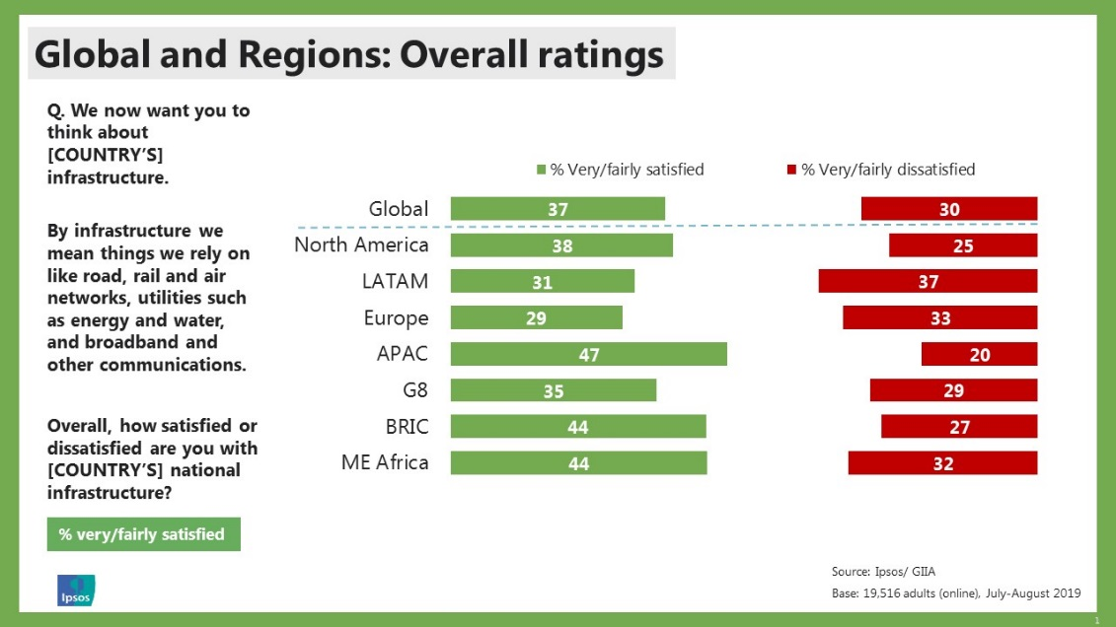
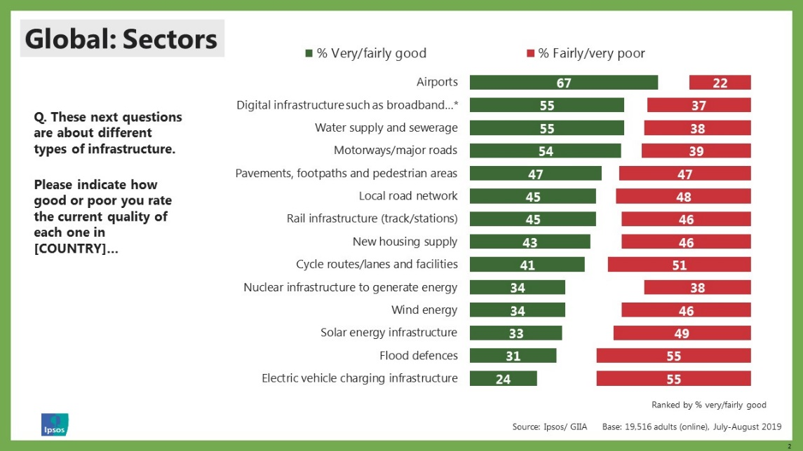
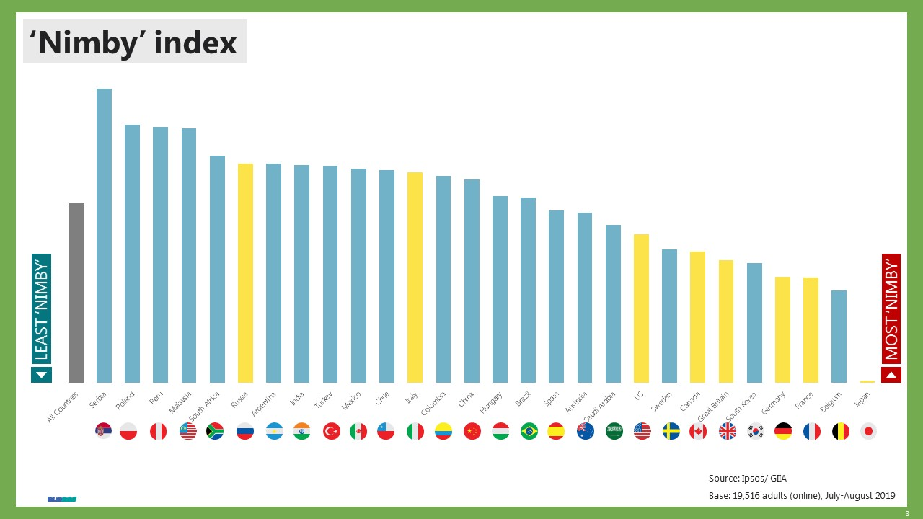

NOTES TO EDITORS
- For media enquiries please contact:
Jon Phillips (GIIA) on 07812 554 008 / 020 3440 3923
Hannah Millard (Ipsos MORI) on 07554 115774 / 020 7347 3452
- Full results available from www.ipsos-mori.com
- The GIIA/Ipsos Infrastructure Index involved 19,516 people sampled via Ipsos’ Global Advisor in 28 countries (samples sizes were either 500 or 1,000 in each country): Argentina, Australia, Belgium, Brazil, Canada, Chile, China, Colombia, France, Germany, Great Britain, Hungary, India, Italy, Japan, Malaysia, Mexico, Peru, Poland, Russia, Saudi Arabia, South Africa, South Korea, Serbia, Spain, Sweden, Turkey and the United States of America

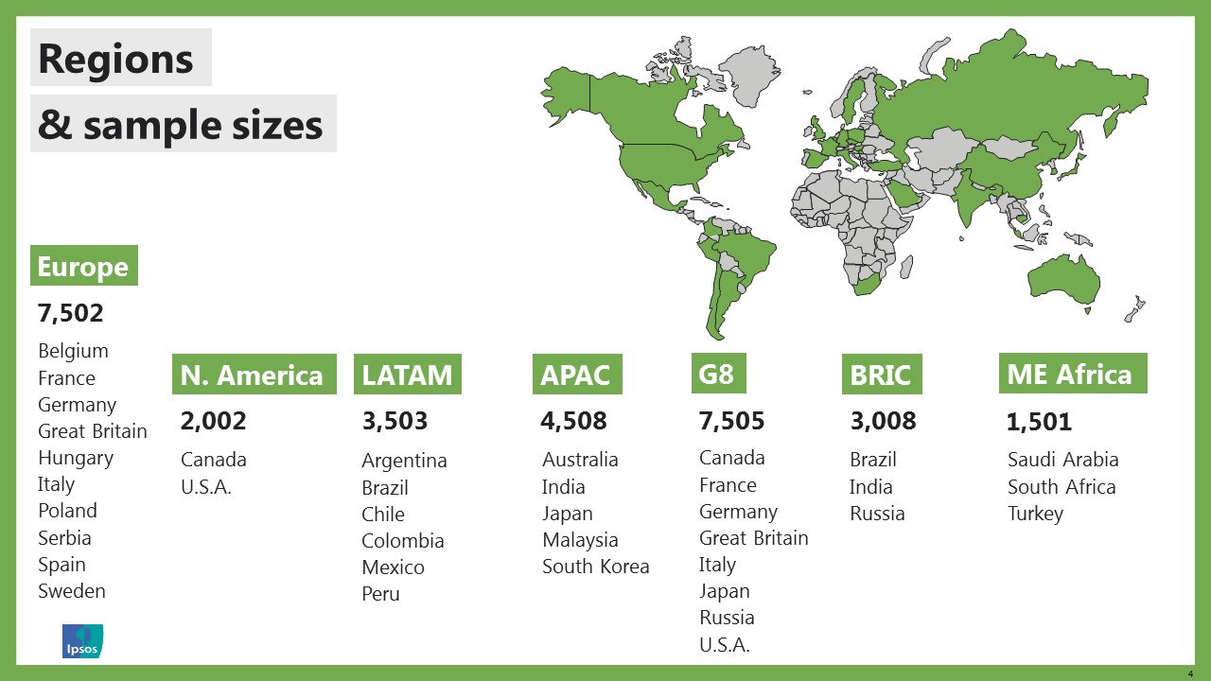

- Surveys were conducted online between 26 July and 9 August 2019 among adults aged 18-64 in the US and Canada and adults aged 16-64 in all other countries

- Data has been weighted to known country population profiles

About GIIA
Global Infrastructure Investor Association (GIIA) is the membership body for the world’s leading institutional investors. On their behalf, we work with governments and other stakeholders to promote the role of private investment in providing infrastructure that improves national, regional and local economies. Collectively, GIIA members have more than $660bn in infrastructure assets under management across 48 countries.

Ends

